adam 1e3 0
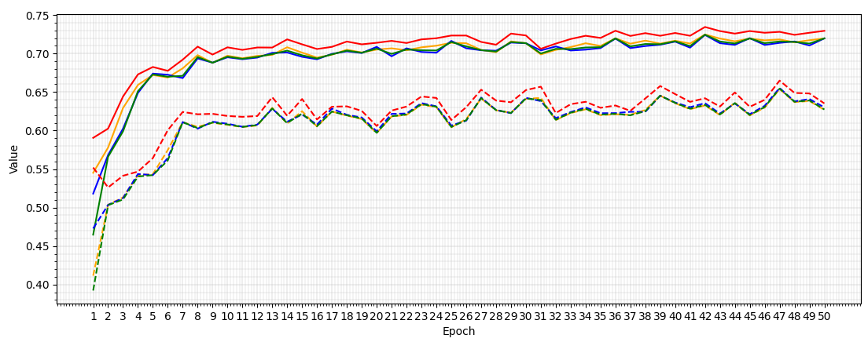
Macro-F1 first above 0.7 at epoch 14
Sample-level - Epoch 42:  Macro-F1: 0.7244  Macro-Precision: 0.7247  Macro-Recall: 0.7241  Accuracy: 0.7344 | Variant-level - Epoch 47:  Macro-F1: 0.6544  Macro-Precision: 0.6538  Macro-Recall: 0.6552  Accuracy: 0.6648
adam 1e3 1e4
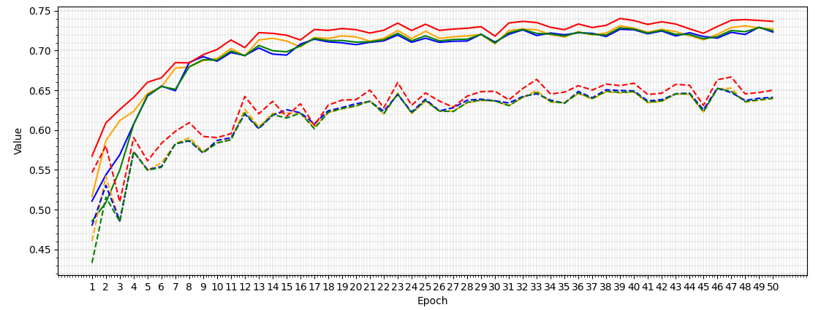
Macro-F1 first above 0.7 at epoch 13
Sample-level - Epoch 49:  Macro-F1: 0.7289  Macro-Precision: 0.7285  Macro-Recall: 0.7293  Accuracy: 0.7378 | Variant-level - Epoch 46:  Macro-F1: 0.6522  Macro-Precision: 0.6518  Macro-Recall: 0.6527  Accuracy: 0.6633
adam 5e4 0
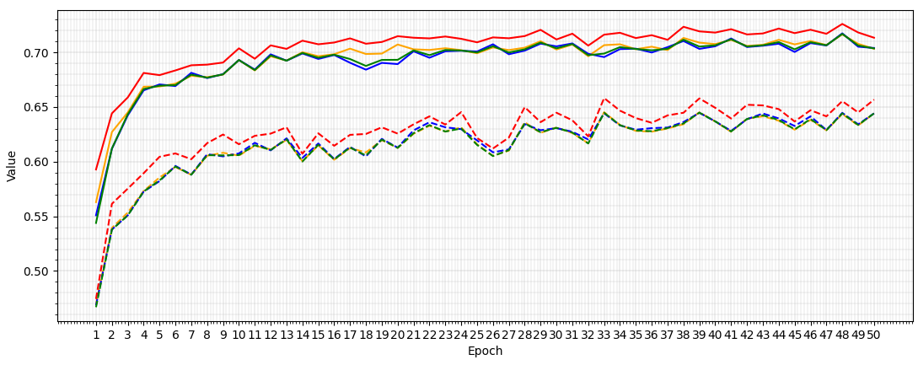
Macro-F1 first above 0.7 at epoch 21
Sample-level - Epoch 48:  Macro-F1: 0.7168  Macro-Precision: 0.7163  Macro-Recall: 0.7173  Accuracy: 0.7259 | Variant-level - Epoch 39:  Macro-F1: 0.6448  Macro-Precision: 0.6451  Macro-Recall: 0.6446  Accuracy: 0.6578
adam 5e4 1e4
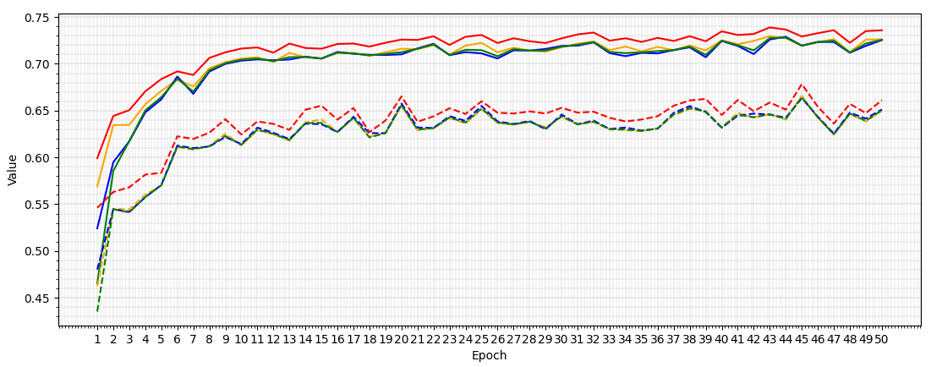
Macro-F1 first above 0.7 at epoch 9
Sample-level - Epoch 44:  Macro-F1: 0.7280  Macro-Precision: 0.7273  Macro-Recall: 0.7289  Accuracy: 0.7366 | Variant-level - Epoch 45:  Macro-F1: 0.6643  Macro-Precision: 0.6657  Macro-Recall: 0.6633  Accuracy: 0.6783
SGD 0.01 0
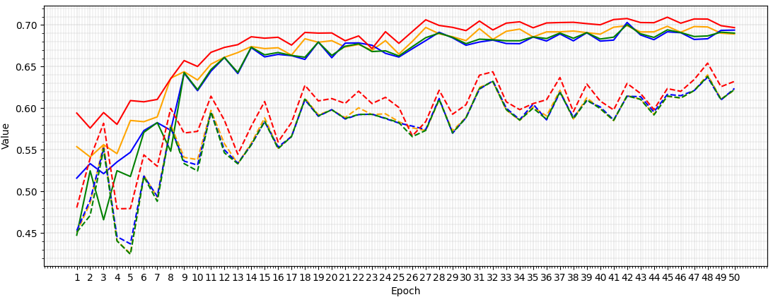
Macro-F1 first above 0.7 at epoch 42
Sample-level - Epoch 42:  Macro-F1: 0.7005  Macro-Precision: 0.6992  Macro-Recall: 0.7031  Accuracy: 0.7078 | Variant-level - Epoch 48:  Macro-F1: 0.6383  Macro-Precision: 0.6401  Macro-Recall: 0.6373  Accuracy: 0.6542
SGD 0.01 1e4
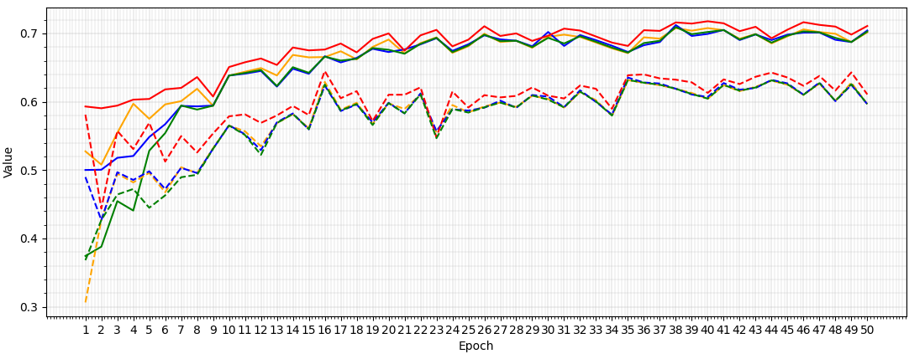
Macro-F1 first above 0.7 at epoch 38
Sample-level - Epoch 38:  Macro-F1: 0.7092  Macro-Precision: 0.7079  Macro-Recall: 0.7122  Accuracy: 0.7161 | Variant-level - Epoch 35:  Macro-F1: 0.6319  Macro-Precision: 0.6317  Macro-Recall: 0.6354  Accuracy: 0.6388
SGD 0.05 0
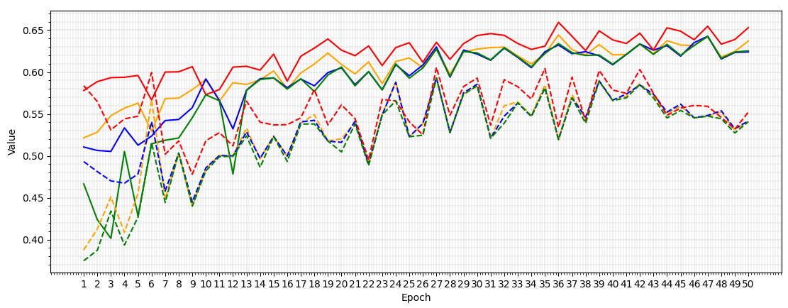
Macro-F1 never exceeded 0.7
Sample-level - Epoch 47:  Macro-F1: 0.6426  Macro-Precision: 0.6424  Macro-Recall: 0.6427  Accuracy: 0.6547 | Variant-level - Epoch 27:  Macro-F1: 0.5929  Macro-Precision: 0.5927  Macro-Recall: 0.5933  Accuracy: 0.6056
SGD 0.05 1e4
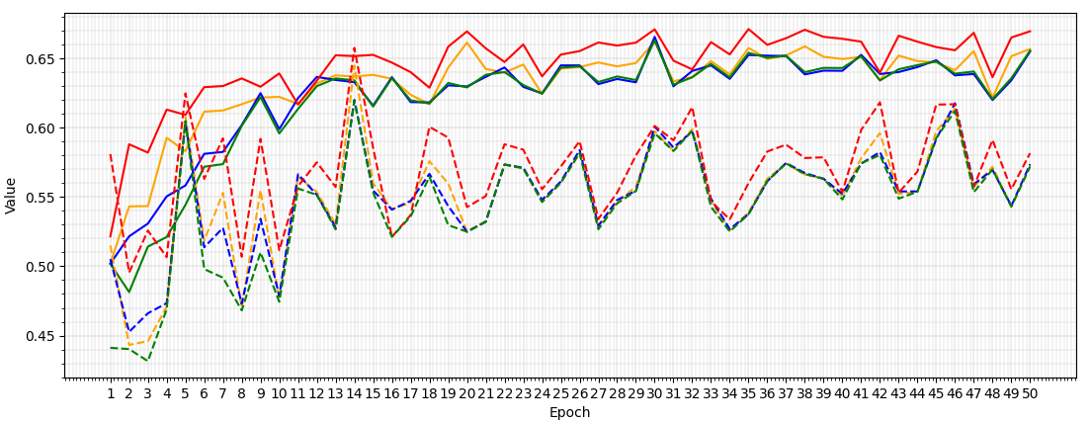
Macro-F1 never exceeded 0.7
Sample-level - Epoch 30:  Macro-F1: 0.6630  Macro-Precision: 0.6621  Macro-Recall: 0.6655  Accuracy: 0.6709 | Variant-level - Epoch 14:  Macro-F1: 0.6194  Macro-Precision: 0.6447  Macro-Recall: 0.6200  Accuracy: 0.6575

